The University of Azad Jammu and Kashmir, Muzaffarabad

Name: Alishba Zakir
Roll No: 2024-SE-02
Course: DataBase Systems
Course Code: CS-2204
Lab: OpenEnded Lab
Submitted To: Engr. Awais Rathore
Submitted By: Alishba Zakir
Date: 21 sep, 2026

Department Of Software Engineering
DATABASE MANAGEMENT SYSTEM
OPEN-ENDED LAB REPORT

SECTION 1: DATABASE DESIGN & IMPLEMENTATION (TASK 1)
1.1 Structural Justification & Schema Design
To eliminate data duplication, redundancy, and entry anomalies, the CarGo Rentals system has been normalized and structured into four separate, logical tables:
- Customers: Manages unique customer profiles. CustomerPhone has a UNIQUE constraint to block multiple profiles using the same number.
- Vehicles: Tracks fleet status. Includes a CHECK constraint on DailyRate to ensure rates are positive, and a Status check string ('Available', 'Rented', 'Maintenance') to enforce real-time availability rules.
- Rentals: The transaction center linking accounts to assets. Employs a custom timeline validation constraint (CHECK (ReturnDate >= RentalDate)).
- Payments: Handles invoicing. Isolates transactional amounts and automates date logging via DEFAULT CURRENT_TIMESTAMP.
1.2 Table Relationships (Cardinality)
- Customers to Rentals (1:M): One customer can rent multiple vehicles over time, but an individual rental receipt belongs to exactly one customer.
- Vehicles to Rentals (1:M): One vehicle can be rented across multiple dates, but one active rental record targets one specific car.
- Rentals to Payments (1:M): A single rental agreement logs structural invoices to verify financial compliance.
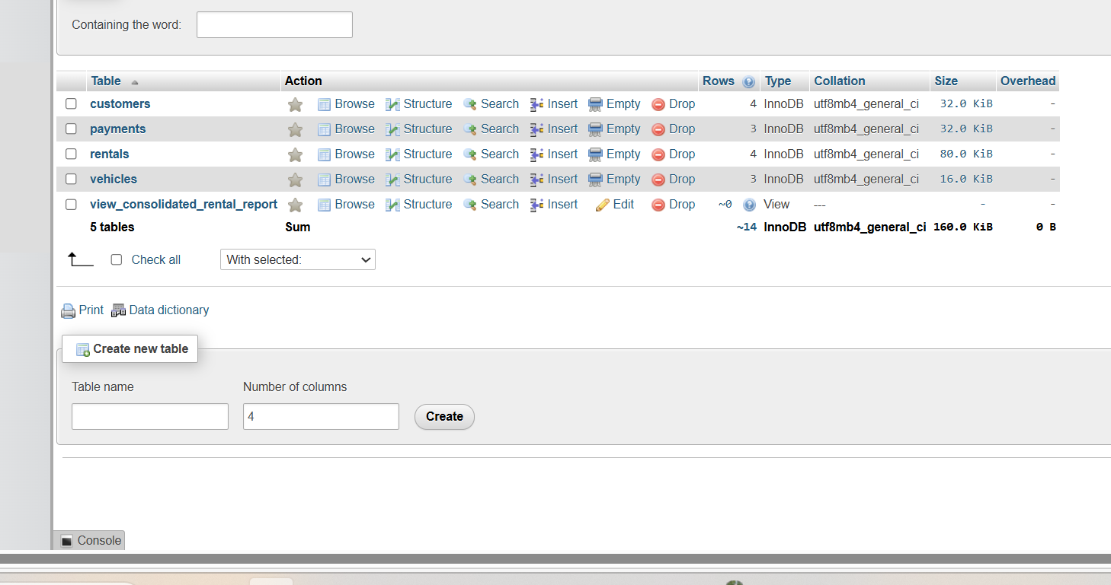
SECTION 2: DATA NORMALIZATION REPORT (TASK 2)
2.1 Unnormalized Form (UNF) Analysis
The baseline layout stores everything in a flat file record:
RentalID, CustomerName, CustomerPhone, VehicleNumber, VehicleModel, DailyRate, RentalDate, ReturnDate, PaymentAmount
Redundancy / Anomalies: If a customer registers multiple bookings, their name and telephone details must be duplicated manually. Updating a vehicle's base price requires scanning thousands of transaction items, causing Update Anomalies.
2.2 First Normal Form (1NF)
Action: Ensure atomic, non-repeating multi-valued attributes per cell.
Evaluation: The spreadsheet satisfies 1NF parameters structurally as cells hold single values, but it lacks structural dependency controls.
2.3 Second Normal Form (2NF)
Action: Eliminate partial functional dependencies. All attributes must fully depend on the primary key, RentalID.
Decomposition: Separating entity attributes:
- Customers (CustomerID [PK], CustomerName, CustomerPhone)
- Vehicles (VehicleNumber [PK], VehicleModel, DailyRate)
- Rentals (RentalID [PK], CustomerID [FK], VehicleNumber [FK], RentalDate, ReturnDate, PaymentAmount)
2.4 Third Normal Form (3NF)
Action: Remove transitive dependencies (non-prime attributes relying on other non-prime attributes).
Decomposition: PaymentAmount relies directly on the financial invoice balance process, not the lease configuration setup.
- Payments (PaymentID [PK], RentalID [FK], PaymentAmount, PaymentDate)
SECTION 3: OPERATIONAL BUSINESS QUERIES (TASK 3)
Query 3.1: Display customer name, vehicle number, vehicle model, rental date, and return date for every rental.
SELECT c.CustomerName, r.VehicleNumber, v.VehicleModel, r.RentalDate, r.ReturnDate
FROM Rentals r
INNER JOIN Customers c ON r.CustomerID = c.CustomerID
INNER JOIN Vehicles v ON r.VehicleNumber = v.VehicleNumber;
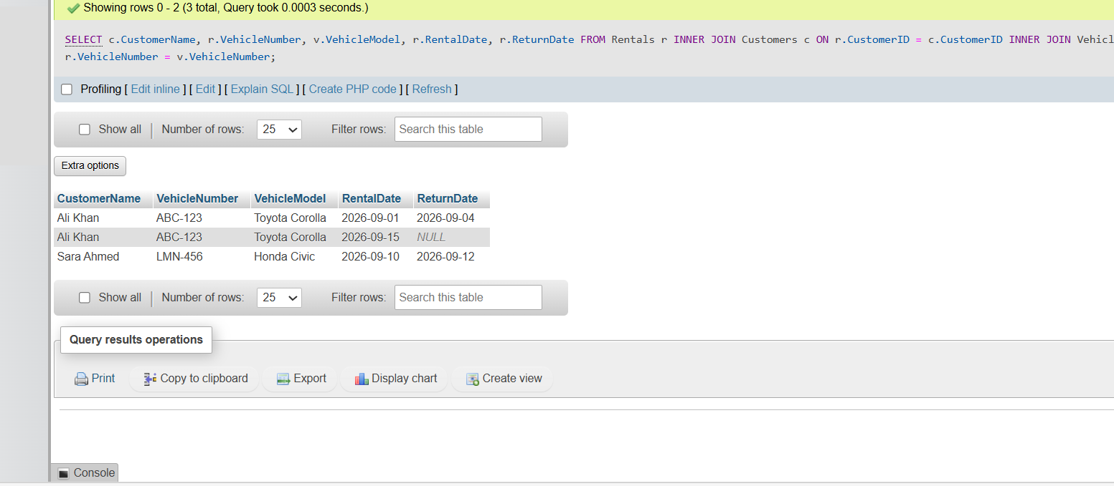

Query 3.2: Display all customers and the vehicles they have rented (including those who have never rented).
SELECT c.CustomerName, r.RentalID, r.VehicleNumber
FROM Customers c
LEFT JOIN Rentals r ON c.CustomerID = r.CustomerID;
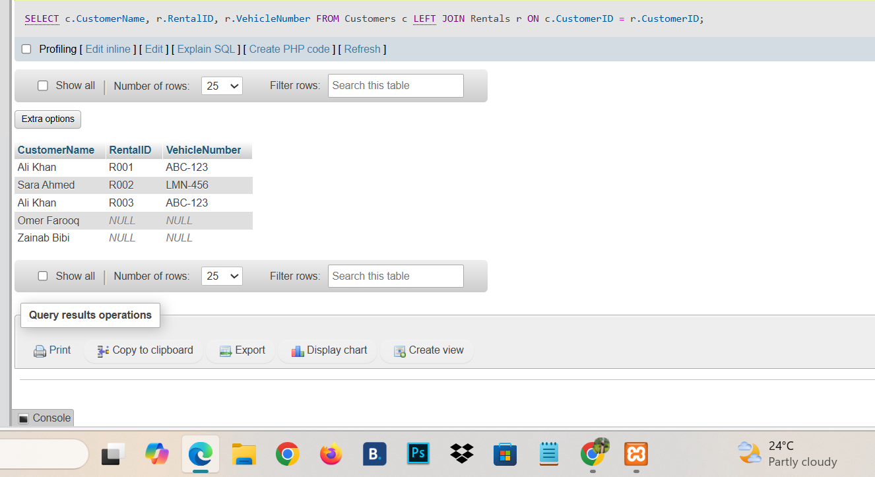

Query 3.3: Display all vehicles and their current rental details (including unrented vehicles).
SELECT v.VehicleNumber, v.VehicleModel, v.Status, r.RentalID, r.RentalDate
FROM Vehicles v
LEFT JOIN Rentals r ON v.VehicleNumber = r.VehicleNumber AND r.ReturnDate IS NULL;
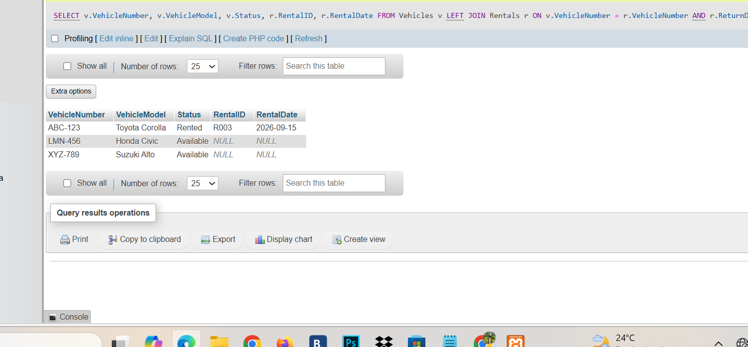

Query 3.4: Display the total number of rentals made by each customer.
SELECT c.CustomerName, COUNT(r.RentalID) AS TotalRentals
FROM Customers c
LEFT JOIN Rentals r ON c.CustomerID = r.CustomerID
GROUP BY c.CustomerID, c.CustomerName;
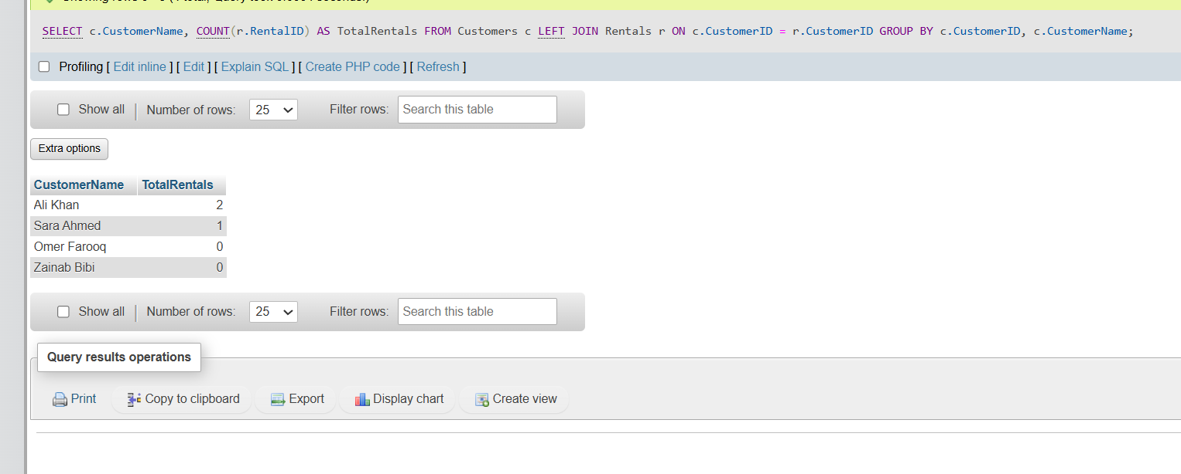

SECTION 4: MASTER CONSOLIDATED DATA VIEW (TASK 4)
4.1 SQL Implementation Statement
CREATE VIEW View_Consolidated_Rental_Report AS
SELECT r.RentalID, c.CustomerName, c.CustomerPhone, v.VehicleNumber, v.VehicleModel, r.RentalDate, r.ReturnDate, COALESCE(p.PaymentAmount, 0.00) AS PaidAmount
FROM Rentals r
INNER JOIN Customers c ON r.CustomerID = c.CustomerID
INNER JOIN Vehicles v ON r.VehicleNumber = v.VehicleNumber
LEFT JOIN Payments p ON r.RentalID = p.RentalID;
Testing View Command: SELECT * FROM View_Consolidated_Rental_Report;
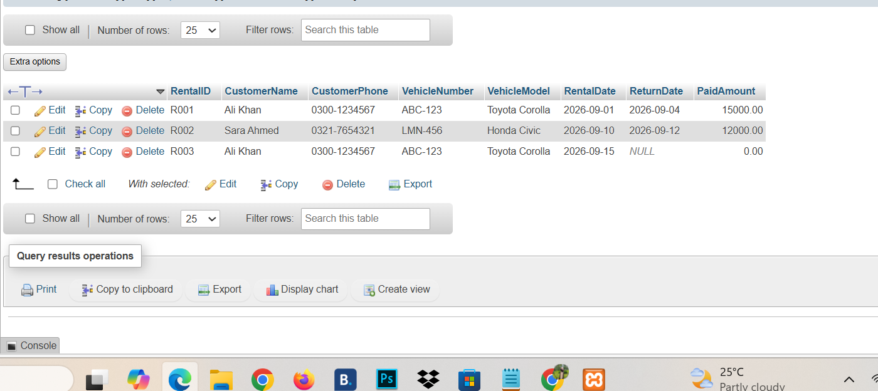
Why the view is useful?
This consolidated View abstracts the underlying multi-table schema complexity into a single queryable object. Management can evaluate lease records or review customer payment history directly without writing complex multi-table JOIN statements every time.
SECTION 5: SYSTEM AUTOMATION TRIGGER (TASK 5)
5.1 SQL Implementation Statement
CREATE TRIGGER After_Rental_Insert
AFTER INSERT ON Rentals
FOR EACH ROW
BEGIN
UPDATE Vehicles
SET Status = 'Rented'
WHERE VehicleNumber = NEW.VehicleNumber;
END; 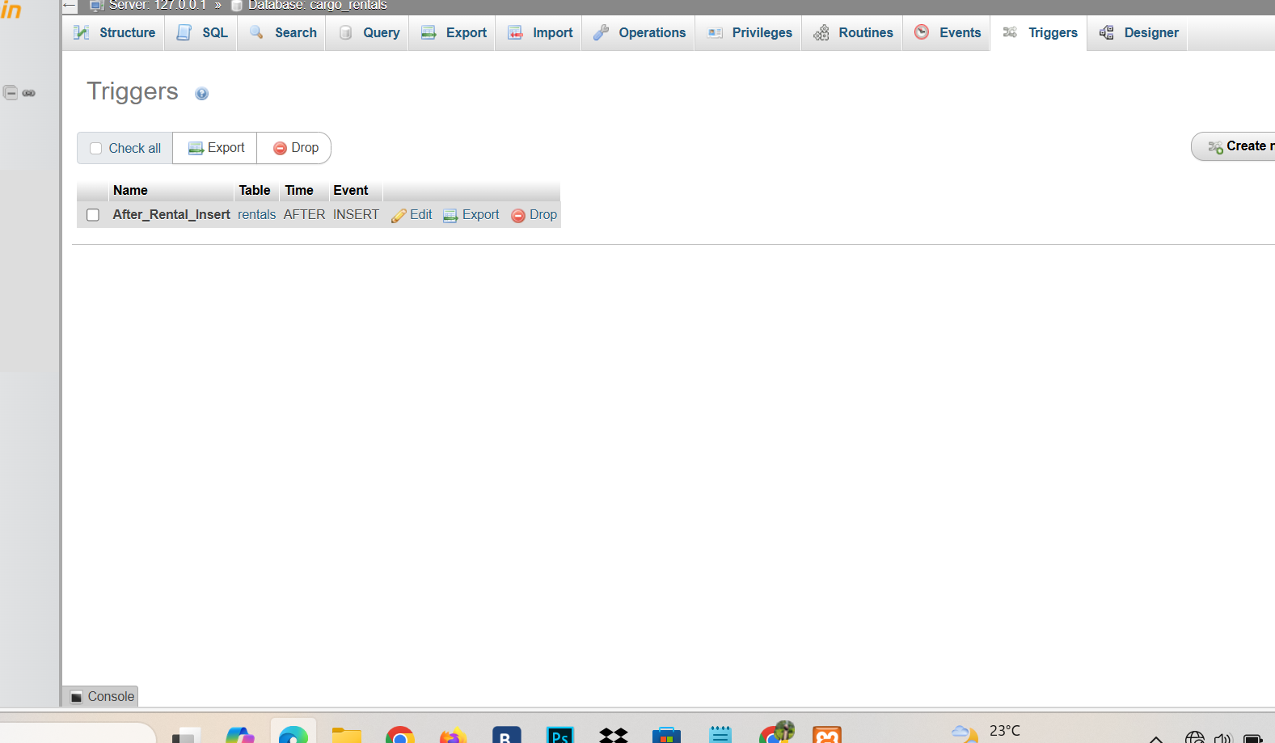

SECTION 6: TRANS-LOGIC STORED PROCEDURE (TASK 6)
6.1 SQL Implementation Statement
CREATE PROCEDURE RegisterNewRental(
IN p_RentalID VARCHAR(20),
IN p_CustomerID INT,
IN p_VehicleNumber VARCHAR(20),
IN p_RentalDate DATE,
IN p_ReturnDate DATE
)
BEGIN
INSERT INTO Rentals (RentalID, CustomerID, VehicleNumber, RentalDate, ReturnDate)
VALUES (p_RentalID, p_CustomerID, p_VehicleNumber, p_RentalDate, p_ReturnDate);
END;
Testing Stored Procedure Command: CALL RegisterNewRental('R005', 2, 'LMN-456', '2026-09-20', '2026-09-22');
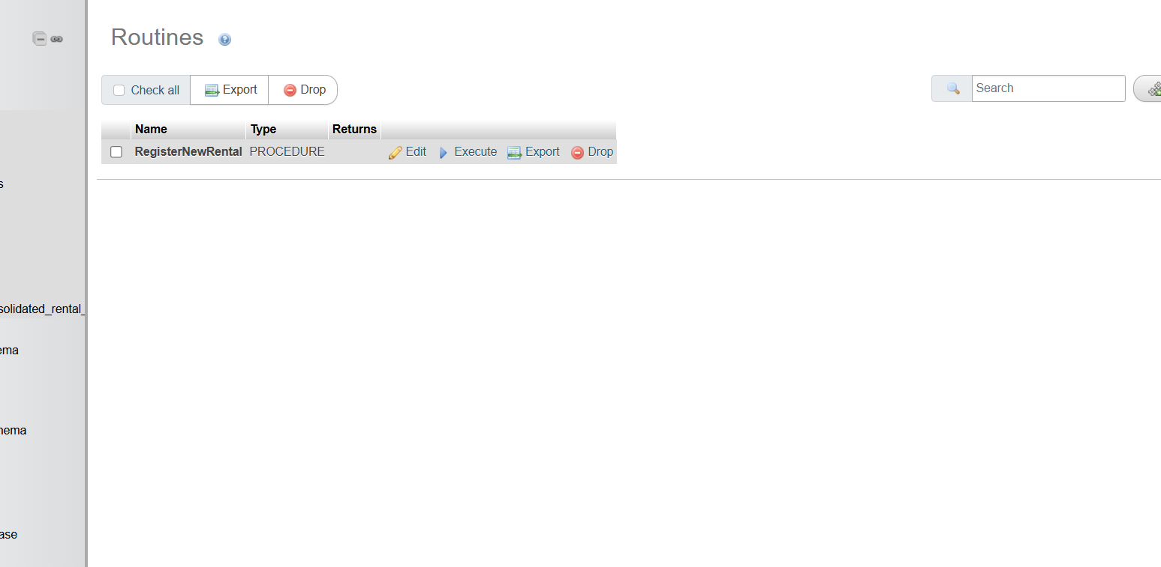
SECTION 7: OPTIMIZATION PERFORMANCE ANALYSIS (TASK 7)
7.1 Identified Inefficiency
The data system processes analytical search requirements (like filtering records via WHERE ReturnDate IS NULL or tracking entries by CustomerID) using full table scans. As transactional rows scale up over time, query performance will decline.
7.2 Mitigation via Index Tuning
Creating standard indexes sets up optimized lookup tables inside the database engine. This prevents high resource consumption and reduces data lookup latency.
CREATE INDEX idx_rentals_customer ON Rentals(CustomerID);
CREATE INDEX idx_rentals_active_cars ON Rentals(VehicleNumber, ReturnDate);
